2D GAME:RPG DOCUMENTATION

Bolić Armin

September, 2022

# PART 1:

**INTRODUCTION**

Hero Quest is classic 2d rpg game. It consists of multiple hero classes to choose from and every class has specific skills and attacks. Also every class has its own advantages and disadvantages so the game is balanced. It is single player game, player can move throuh multiple maps, use skills, but also he has to pay attention to energy and health which are crucial in game. There is also ranking system to make game more competitive, and we can see top players by points in leaderboards.

# PART 2:

# PROJECT OVERVIEW

**2.1. Technologies**

The technologies used for the project are:

*- Python*

*- PyGame - python library for developing 2d games*

*- MySql*

**2.2. Project Structure**

The Diagram 1. below shows the *Client Journey.* When a client enters the game*,*  he is directed to login/register page where he can choose whether he has account or not. After succesfully logging in or registering, he is directed to main menu. From main menu he can access leaderboards, admin page if he is admin, options and game itself.

**REGISTER**

**MAIN MENU**

**LEADERBOARDS**

**ADMIN PAGE(as admin)**

**LOGIN**

**HERO SELECTION**

**CLASS INFORMATION**

**GAMEPLAY**

**CLASS SPELLS**

For register, there is 4 fields:

Email,

Nickname,

Password,

Password confirmation.

Each segment is checked individually(checking if email or nickname are taken and checking if password is same as confirmation password)

If everything is valid, user will succesfully enter the game and their account informations will be added in database.

Login has 2 fields:

Email,

Password.

In login function system checks if email is in database and if it is then it checks does email and password matches. If it matches, user will be directed to mainmenu.

There are 2 groups of players:

Admin – Admin can access admin page, where he can ban players for set amount of hours, and he can delete player accounts. Admin can also access all other game funcitonalities.

Player – Players can access all of game functionalities, can check leaderboards, choose hero and play game.

# PART 3:

# TECHNICAL DOCUMENTATION

This section fully covers all and each of project`s functionalities in details, so that its structure, functionalities, and usage are simple and understandable to any stakeholder interested.

As stated in the previous section, this project consists of four main parts – namely *Login/Register, Main Menu, Leaderboards, Admin Page, Hero selection, Hero Info, Hero spells, Gameplay* and the technical documentation is provided in that order as well.

The description of the modules is followed up by the images – screenshots – of the webpage.

## 3.1. Technical Documentation: Login/Register

The *Login/Register page(Image 1.1, Image 1.2)* consists of multiple fields that needs to be filled in in order to login and register. Also it needs to pass validation. In register, if any of the fields are left blank, it will show a message:”You need to fill in all of the requirements”(Image 1.3). If email or nickname are already taken or email is not in valid form it will show a message:”Email/nickname already taken”(Image 1.4, Image 1.5, Image 1.6). If password doesn’t match the password confirmation it will shot a message:”Password doesn’t match”(Image 1.7).

In login, if email is not in the database, it will show a message:”There is no account linked to that email”(Image 1.8). If password is does not match with email it will show message:”Password is incorrect”(Image 1.9).

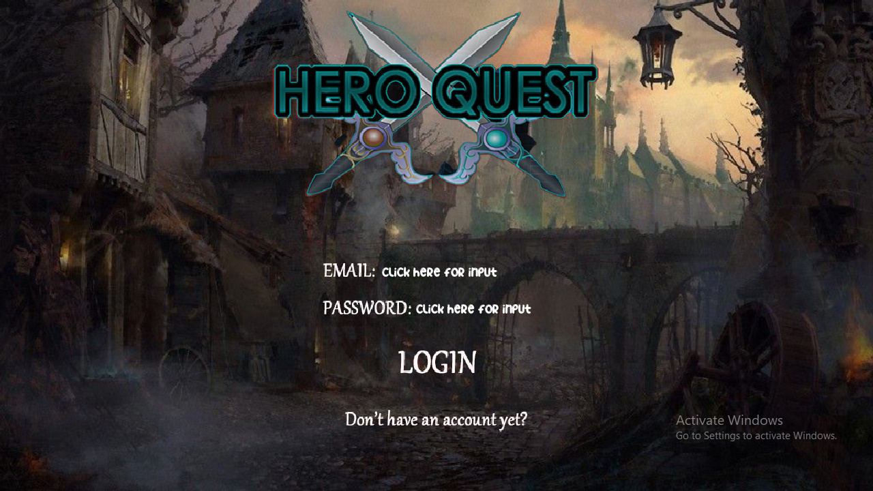

(**Image 1.1**: Login Page)

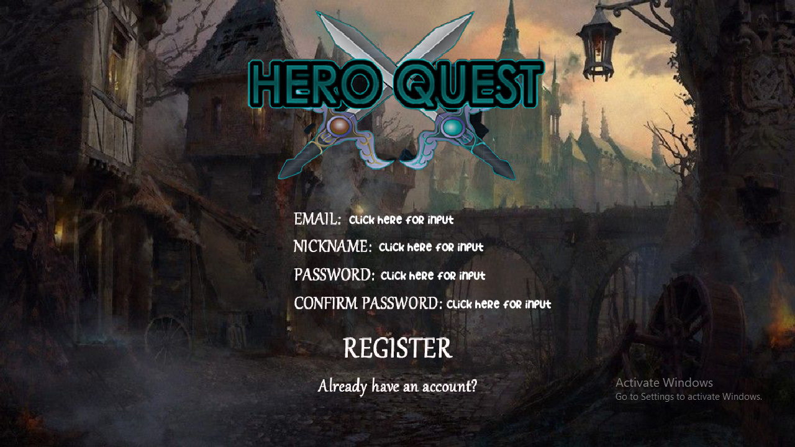

(**Image 1.2**: Register Page)

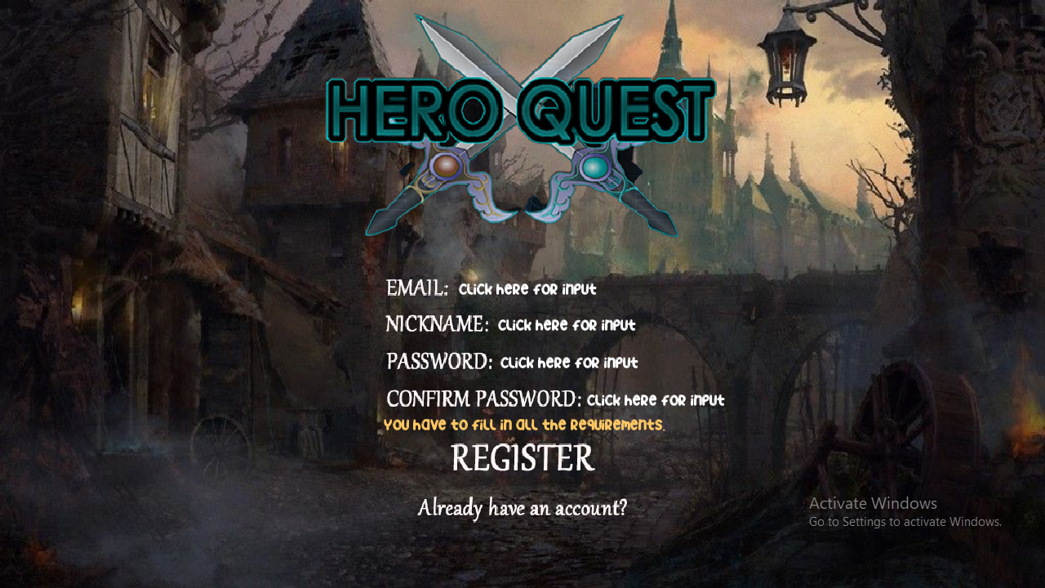

(**Image 1.3**: Register Page Error)

### 

(**Image 1.4**: Register Page Error)

### 

(**Image 1.5**: Register Page Error)

### 

(**Image 1.6**: Register Page Error)

### 

(**Image 1.7**: Register Page Error)

### 

(**Image 1.8**: Login Page Error)

### 

(**Image 1.9**: Login Page Error)

### 3.2. Technical Documentation: Main Menu

**Description:**

**As a User,** I want to be able to access start button, options, leaderboards and exit button.

**As an Admin,** I want to be able to access start button, options, leaderboards, exit button and admin page.

The Main Menu is shown on the Image 2.0. below the acceptance criteria list.

**Acceptance Criteria:**

**As I user:**

* I can see the logo
* I can click on start button to open hero selector
* I can click on options button to open options
* I can click on leaderboards button to open leaderboards
* I can click on exit button to exit the game
* I can log out of account

**As an Admin:**

* I can see the logo
* I can click on start button to open hero selector
* I can click on options button to open options
* I can click on leaderboards button to open leaderboards
* I can click on admin page button to opet admin page
* I can click on exit button to exit the game
* I can log out of account

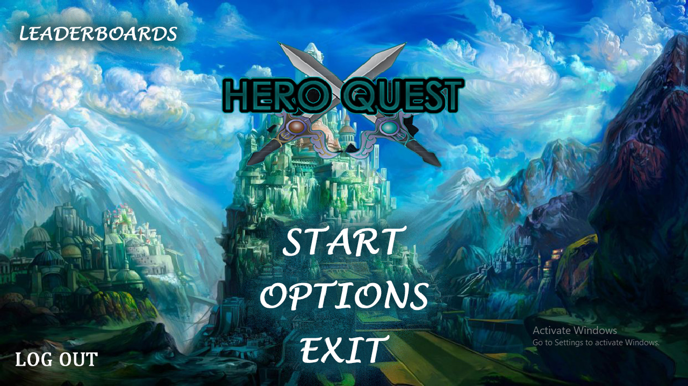

(**Image 1.9**: Main Menu)

### 3.3. Technical Documentation: Leaderboards

In leaderboards window player can see current top 7 players in the game by amount of points as well as his current rank and points.

The Leaderboards is shown on the Image 2.1. below the acceptance criteria list.

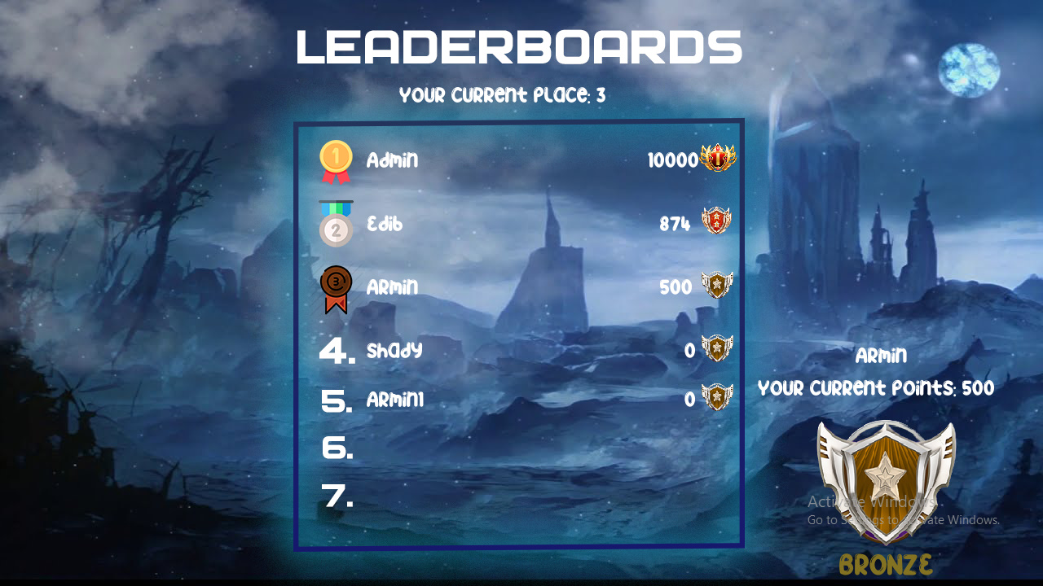

(**Image 2.1**: Leaderboards)

### 3.4. Technical Documentation: Admin Page

The Admin Page is shown on the Image 2.2. below the acceptance criteria list.

**Acceptance Criteria:**

**As an Admin:**

* I can ban people(Image 2.3)
* I can delete accounts from database(Image 2.4)
* I can see all of the players, aswell as their ids and ban durations

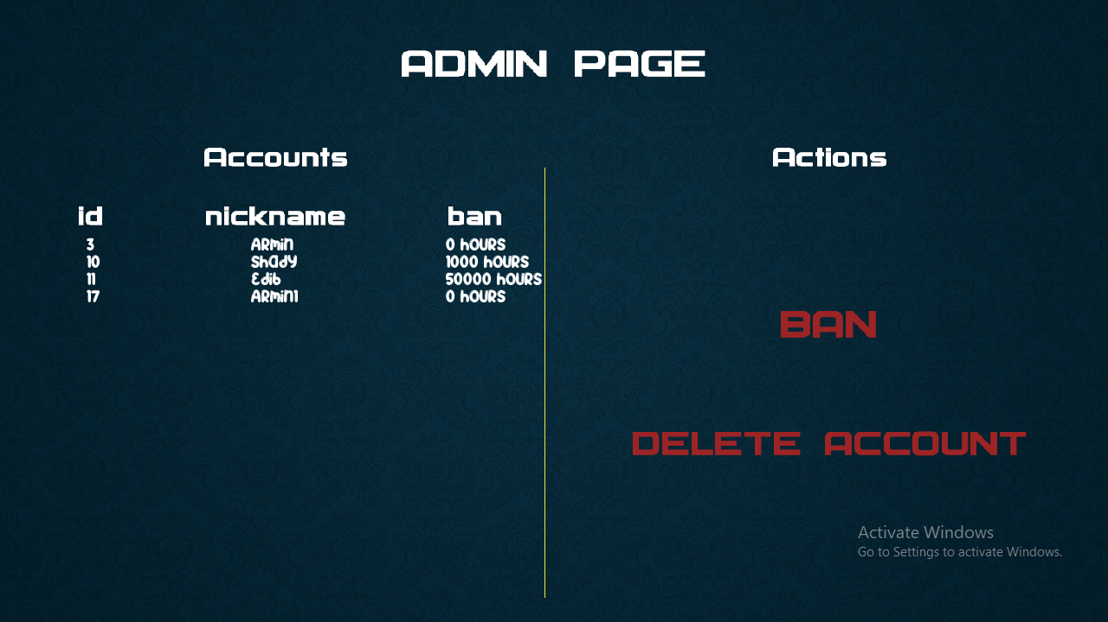

(**Image 2.2**: Admin Page)

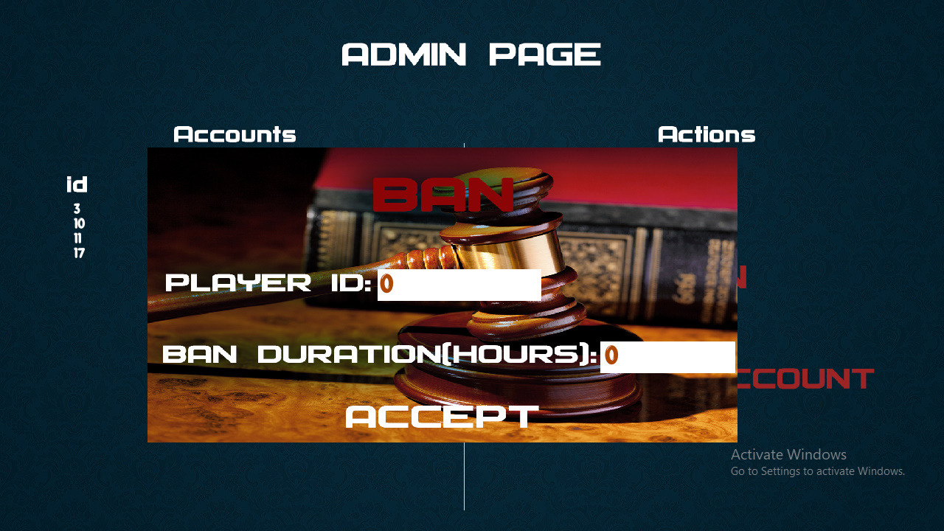

(**Image 2.3**: Ban)

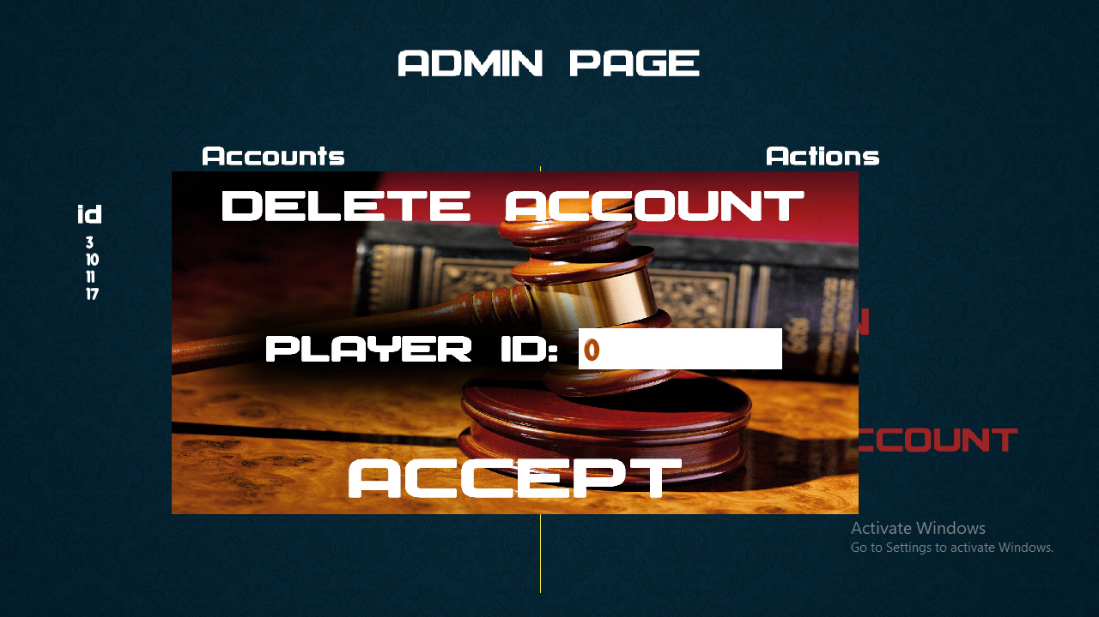

(**Image 2.4**: Delete Account)

### 3.5 Technical Documentation: Hero Selection

The Hero Selection is shown on the Image 2.5. below the acceptance criteria list.

**Acceptance Criteria:**

**As I user:**

* I can choose from one of 4 classes(Image 2.5)

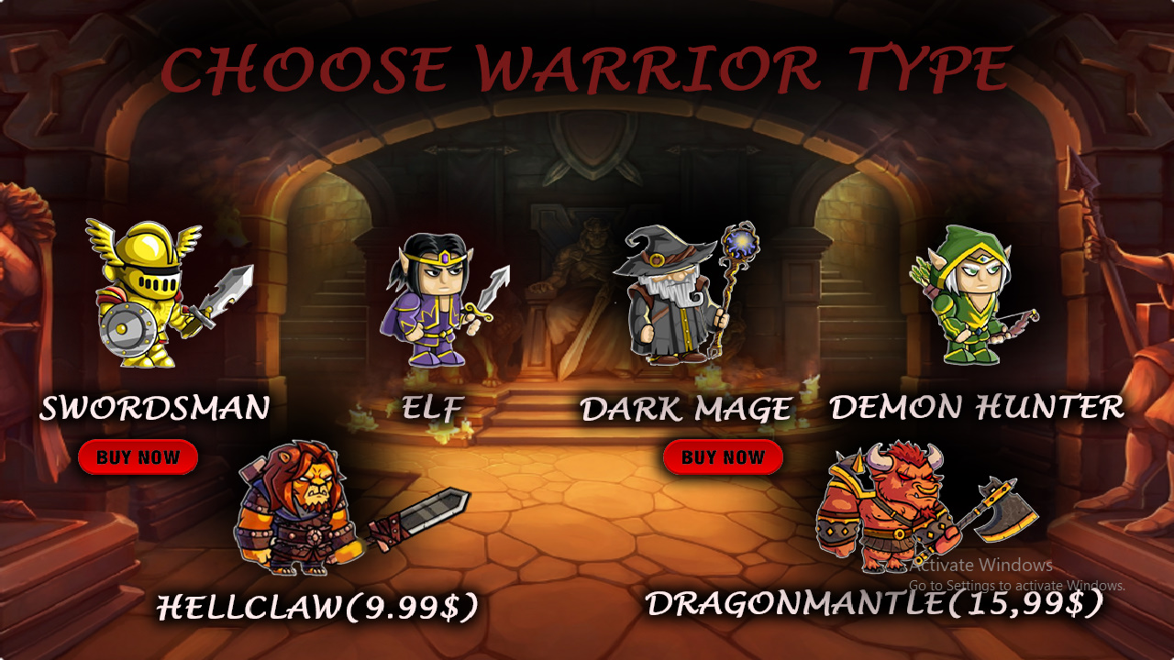

(**Image 2.5**: Hero Selection)

### 3.6. Technical Documentation: Hero Info

**Acceptance Criteria:**

**As I user:**

* I can proceed to chosen class spells
* I can see hero informations, advantages and disadvantages(Image 2.6)

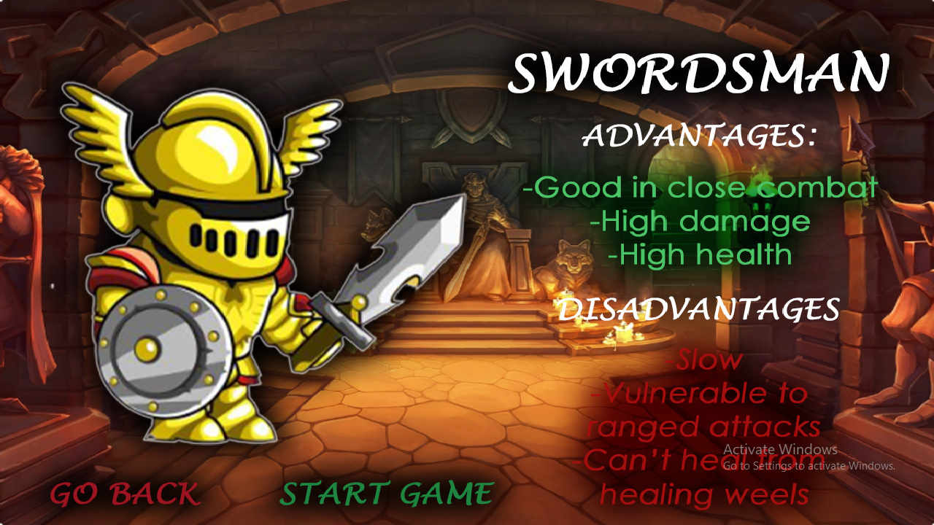

(**Image 2.6**: Hero Info)

### 3.7. Module Hero Skills

**Acceptance Criteria:**

**As I user:**

* I can see what spells does chosen class use(Image 2.7)

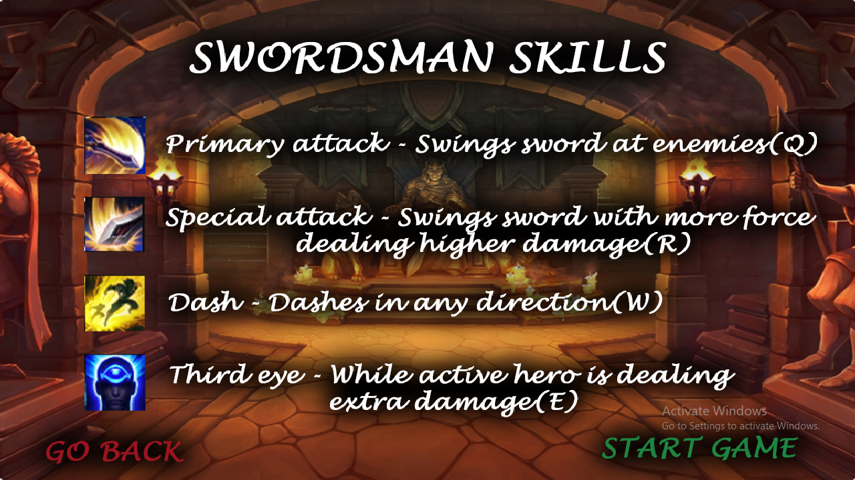

(**Image 2.7**: Hero Skills)

### 3.8. Technical Documentation: Gameplay

The Hero Selection is shown on the Image 2.8. below the acceptance criteria list.

**Acceptance Criteria:**

**As I user:**

* I can move my character around the map
* I can move between multiple maps
* I can use one of four skills(each skill has specific cooldown or uses energy)
* I can see current health, current energy, current skills cooldown counter

.

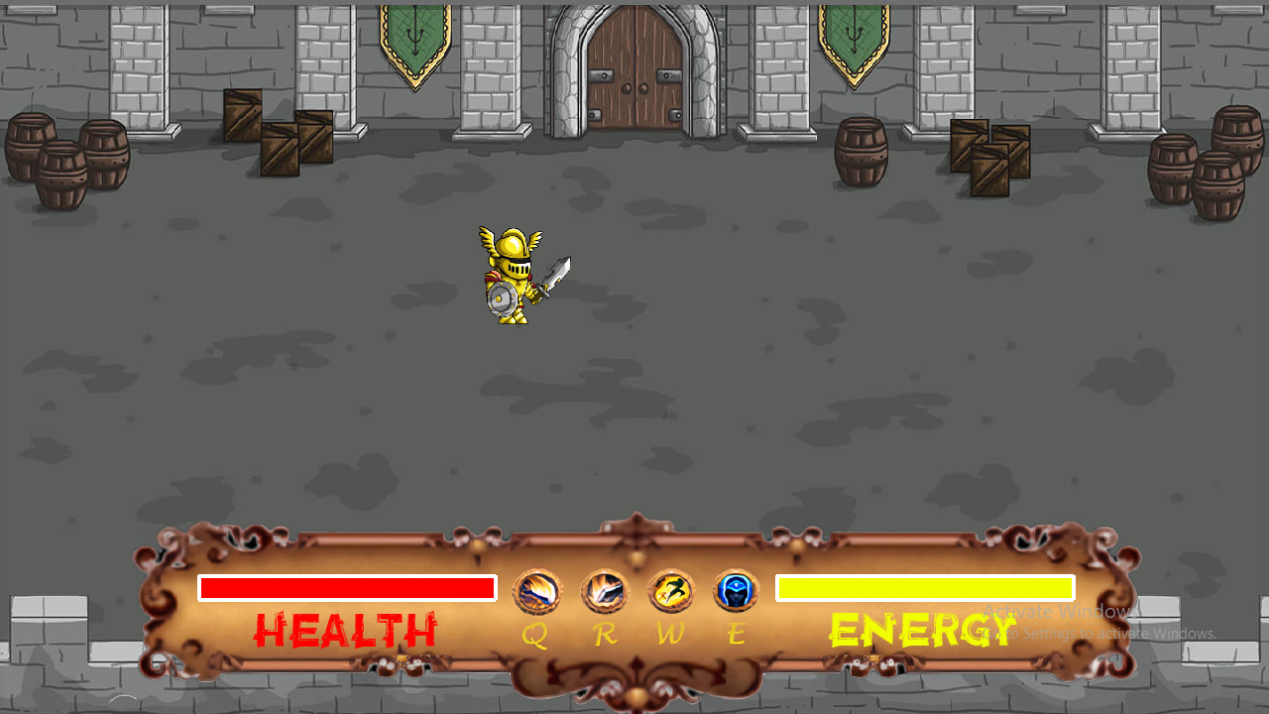

(**Image 2.8**: Gameplay)

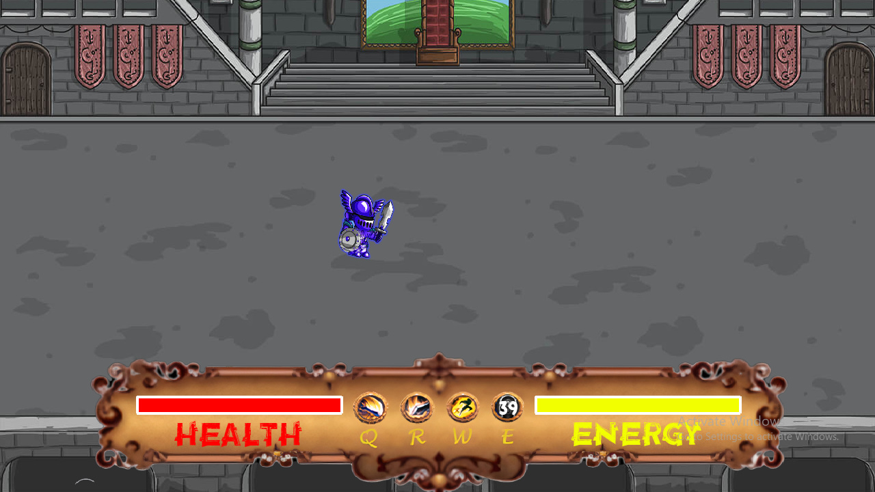

(**Image 2.9**: Using skill example)

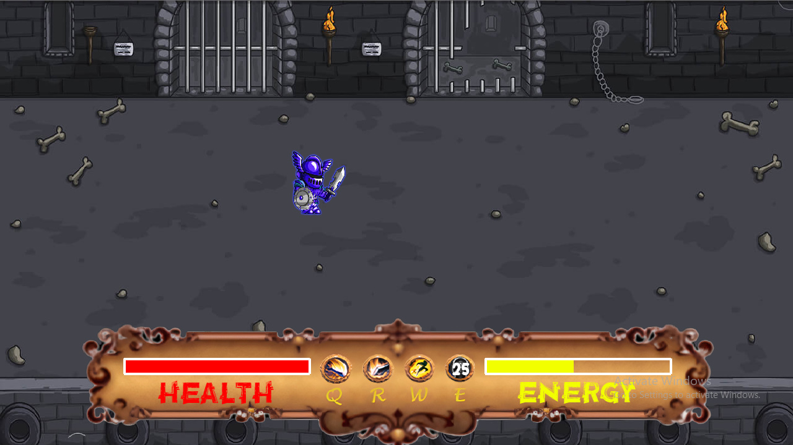

(**Image 3.0**: Using skill example)

**PART 4:**

**CONCLUSION**

This is demo version of this game. In order to make it fully functional game few improvements need to be done:

1.Options

-Add resolution change in options

-Add key bind configurations

2.Hero classes

-Add posibillity to play all classes

3.Gameplay

-Add combat and combat logic

4.Multiplayer

-Add multiplayer PvP(player versus player) gameplay